2024 Annual Report to the School Community
 | - all teachers at the school meet the registration requirements of the Victorian Institute of Teaching (VIT)  - the school meets prescribed Minimum Standards for registration as regulated by the Victorian Regulation and Qualifications Authority (VRQA) in accordance with the Education and Training Reform Act 2006 (Vic) (this includes any exemption granted to this school by the VRQA, for the most recent calendar year, in relation to minimum student enrolment numbers and/or the curriculum framework requirement to deliver a languages program)  - the school meets the requirements of the Child Safe Standards as prescribed in Ministerial Order 1359 – Implementing the Child Safe Standards – Managing the risk of child abuse in schools (PDF).  Attested on 30 April 2025 at 02:06 PM by Imogen Lippiatt (Principal)  - As executive officer of the school council, I attest that this 2024 Annual Report to the School Community has been tabled and endorsed at a meeting of the school council and will be publicly shared with the school community.  Attested on 02 May 2025 at 03:21 PM by Imogen Lippiatt (Principal)

School Name: Malvern Central School (1604)

How to read the Annual Report
What does the ‘About Our School’ commentary section of this report refer to?
The ‘About our school’ commentary provides a brief background on the school and an overview of the school’s performance over the previous calendar year.
The ‘School Context’ describes the school’s vision, values, and purpose. Details include the school’s geographic location, size and structure, social characteristics, enrolment characteristics, and special programs.
The ‘Progress towards strategic goals, student outcomes, and student engagement’ section allows schools to reflect on highlights related to implementation of and progress towards the School Strategic Plan and Annual Implementation Plan, and efforts to improve student learning, wellbeing, and engagement.
What does the ‘Performance Summary’ section of this report refer to?
The Performance Summary includes the following:
School Profile
- student enrolment information
- the school’s ‘Student Family Occupation and Education’ category
- a summary of parent responses in the Parent Opinion Survey, shown against the statewide average for Primary schools
- school staff responses in the area of School Climate in the School Staff Survey, shown against the statewide average for Primary schools
Learning
- English and Mathematics for Teacher Judgements against the curriculum
- English and Mathematics for National Literacy and Numeracy tests (NAPLAN).
Wellbeing
Student responses to two areas in the Student Attitudes to School Survey:
- Sense of Connectedness
- Management of Bullying
Engagement
- Student attendance at school
Results are displayed for the latest year and the average of the last four years (where available).
Key terms used in the Performance Summary are defined below:
Similar Schools
Similar Schools are a group of Victorian government schools with similar characteristics to the school.
This grouping of schools has been created by comparing each school’s socio-economic background of students, the number of non-English speaking students and the school’s size and location.
NDP and NDA
NDP’ refers to no data being published for privacy reasons or where there are insufficient underlying data. For example, very low numbers of participants or characteristics that may lead to identification will result in an ‘NDP’ label.
‘NDA’ refers to no data being available. Some schools have no data for particular measures due to low enrolments. There may be no students enrolled in some year levels, so school comparisons are not possible.
Note that new schools only have the latest year of data and no comparative data from previous years. The department also recognises unique circumstances in Specialist, Select Entry, English Language, Community Schools and schools that changed school type recently, where school-to-school comparisons are not appropriate.

The Victorian Curriculum
The Victorian Curriculum F–10 sets out what every student should learn during his or her first eleven years of schooling. The curriculum is the common set of knowledge and skills required by students for life-long learning, social development and active and informed citizenship.
The Victorian Curriculum is assessed through teacher judgements of student achievement based on classroom learning.
The curriculum has been developed to ensure that school subjects and their achievement standards enable continuous learning for all students, including students with disabilities.
The ‘Towards Foundation Level Victorian Curriculum’ is integrated directly into the curriculum and is referred to as ‘Levels A to D’.
‘Levels A to D’ may be used for students with disabilities or students who may have additional learning needs. These levels are not associated with any set age or year level that links chronological age to cognitive progress (i.e., there is no age expected standard of achievement for ‘Levels A to D’).
Updates to the ‘Performance Summary’ in the 2024 Annual Report
Reporting on the following measures has been updated in the 2024 Annual Report to align with changes to departmental and public reporting products.
NAPLAN
In 2023 NAPLAN was updated to report against proficiency standards. For further information on the changes to NAPLAN reporting in 2023, please refer to the National Assessment Program ‘Results and Reports’ page.
In line with these changes, the NAPLAN section of the Performance Summary includes NAPLAN data from 2022 to 2024. 2022 NAPLAN data is presented separately as this is not comparable with 2023 and 2024.
The NAPLAN section has been updated to include a 2-year average (2023 and 2024) for the percentage of students in the Strong or Exceeding proficiency levels. The 2022 NAPLAN section continues to report on the percentage of students in the top three bands.
Please note the previously reported NAPLAN 4-year average will not be available until 2026, when there will be 4 years’ worth of NAPLAN data available under the new methodology. Similarly, NAPLAN Learning Gain data will not be reported until 2025 as the measure requires at least 3 full years of data for the comparison.

About Our School

School context
Location and history
Malvern Central School is in the City of Stonnington in the south-eastern suburbs of Melbourne, 10 kilometres from the Melbourne CBD. It is a multi-campus school that was established in 1875 as Malvern State School and is the oldest school in the Malvern district. The school is located next to the Malvern Gardens, established in 1888. The second historically significant building on Park Street was established as an Infant School in 1914 where today classrooms are utilised by Foundation to Year 2 students.
School facilities
The school facilities include flexible learning spaces, outdoor play areas, kitchens, soccer ovals, a gymnasium, visual and performing art rooms, library and science laboratory. The school is committed to maintaining and enhancing heritage buildings and student-centred spaces including the playgrounds and gardens.
Enrolments
Enrolment for 2024 was 505 students with the prospect of stable enrolments for the next three years.
SFOE
The Student Family Occupation Education (SFOE) index in 2024 was 0.0919.
School profile
In 2024, the school hosted 23 classes in straight year levels, enhanced by teams of teachers with excellent curriculum knowledge, expertise and a collaborative approach to planning and assessment. The School Improvement Team leads the direction of the school and oversees curriculum design and delivery, teaching and learning programs and the implementation of the School Strategic Plan. The staffing profile of Malvern Central in 2024 included a Principal and Assistant Principal, 2 Learning Specialists, 24 classroom teachers, 4.5 specialist subject teachers, 2 Learning Tutors, 8.5 full time equivalent Education Support staff and Admin staff at both campuses.
School Strategic Plan 2024 - 2028:
In 2024, Malvern Central School participated in a school review (April - May), a process undertaken every four years for government schools. This allowed the school to analyse and interrogate data, surveys and stakeholder feedback to create our new Strategic Plan for 2024- 2028, providing strategic direction for teaching and learning, wellbeing, engagement and community participation. Long term goals for the school over the next four years will focus on:
· student achievement in literacy and numeracy, particularly extending students capable of high achievement
· student agency and ownership over their learning
· student wellbeing programs to build student’s resilience in social and emotional intelligence

Curriculum
A comprehensive curriculum is offered from Foundation to Year 6 following the Victorian Curriculum. The school’s instructional frameworks in key learning areas are based on the gradual release model with a strong emphasis on explicit teaching of skills and the use of learning intentions and success criteria. In 2024, we began to embed a synthetics phonics program in Prep to Year 1 with the prospect of rolling out a more enhanced and rigorous program from Foundation to Year 2. To encourage greater agency across the school, learning goals are co-designed and shared with parents to promote greater understanding and visibility of improvement measures. We continue to provide safe, orderly and engaging classrooms and inspire our young learners in an environment of support, self-regulation and high expectation. Teachers provide personalised learning enhanced by individual learning plans, learning goals and engagement with a range of technology and Science, Technology, Engineering and Mathematics (STEM) programs. Specialist programs include Japanese, visual arts, performing arts and physical education. Students are involved in inter-school sport, camps and house competition events. Students are offered leadership opportunities provided through junior school council, environmental teams, school captaincy, sports house system, performing arts, chess, library and digital technologies.
Additional information
The school is supported by a strong community who share in our values, ethics and mission to produce well rounded, successful and agile learners. We strive to build solid partnerships with our families and provide a school environment that is welcoming and friendly. The School Council consists of both new and long-standing members and is actively involved in school improvement projects and the financial and strategic direction of the school. Over the last three years the Council has delivered major refurbishments to student bathrooms, library and staffrooms, installed new playgrounds and outdoor furniture and developed gardens and streetscapes. The Parents' Club is a committed and dedicated group of parents that contribute each year to school revenue through major fundraising efforts including a bi-annual school fair and MCS Ball, Mother’s and Father’s Day events, parent functions, school discos and sausage sizzles. The school continues to value and appreciate the work of parents and families to support our students and make Malvern Central School a wonderful place to grow and learn.

Progress towards strategic goals, student outcomes and student engagement

Learning
I am pleased to present the results for the Learning subsection of the Annual Report, sharing with you the student outcomes for 2024. The first set of data is for Teacher Judgement, the mark that is given to each student by the teacher for their work and assessments throughout the year. These two data sets for English and Mathematics show the percentage of students who have achieved at or above expected standards. Malvern Central School continues to outperform both Similar and State schools in overall student performance in these two critically important learning domains. I am also proud to report that from 2023, we have maintained the percentage in English and improved our percentage in Mathematics from 97.7% to 98.1% so the school is continuing on a strong trajectory of success.
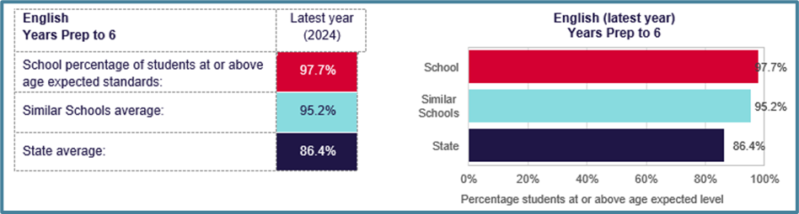
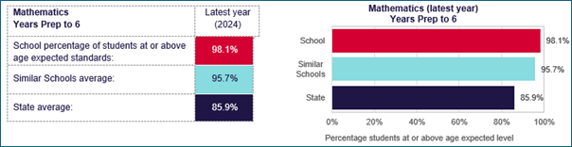
The highlights in 2024 that have contributed to this success have included the school’s work with a Writing Coach. We felt that an external expert would be able to coach and evaluate each teacher’s writing instruction and provide advice and support, particularly around providing each student with quality and timely feedback to improve their writing. By using the workshop model with a focus on providing feedback along with explicit instruction we saw in increase in the percentage of students achieving At standard from 2023 from 39% to 46% with fewer students achieving below standard. Our continual challenge as teachers is to grow the numbers of students in the Above range and to keep them there each year. Another anomaly which comes into play with our results at Malvern Central School is the number of students in the Above range who leave at the end of Year 4, which has a distinct effect on our results.
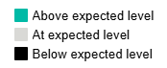
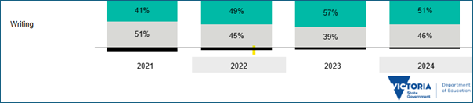
This work in Writing was supported by our Literacy Learning Specialist who provided opportunities for professional learning in Writing, reinforcing high quality teaching and consistency across the school and enabling teachers to learn from each other through Peer Observation and Learning Walks.
In Mathematics, a highlight in 2024 was the successful use of Common Assessment Tasks across the school. These tasks were designed by the Numeracy Curriculum Team as teachers needed another form of assessment in order to get a better understanding of maths knowledge and skills. As a paper-based assessment, in preference to a computer program, there was less room for error and could be observed by the teacher in ‘real’ time. Again, we see the growth in the At expected level from 2023 to 2024, also the growth over 4 years of which the school is extremely proud of.
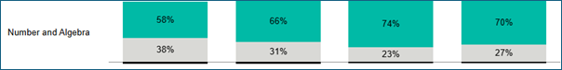
NAPLAN
The second data set to look at is NAPLAN. These are the results for 2024, however only Reading and Numeracy are included in this report. I have provided a table to show the NAPLAN results from Ye ar 3 and 5 in order to gain a wider picture of achievement. When students are assessed through NAPLAN they are categorised as:
· Needs Additional Support (Low)
· Developing
· Strong
· Exceeding (Very High)
The data sets presented in this report show a combined percentage of Strong and Exceeding.
Again, I am very pleased to present our school’s NAPLAN data that indicates similar results in Year 3 and Year 5 Reading to Similar school and a clear outperformance of Similar schools in Mathematics in both Year 3 and Year 5.
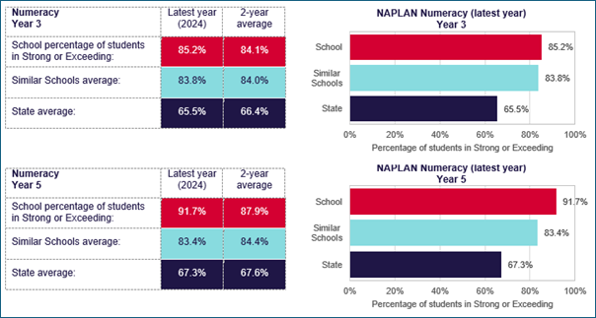
This result has come about with a strong focus on tracking student progress in Mathematics and using assessment data, particularly ‘prior knowledge’ before each topic is taught in order to cater for student misunderstandings and build on skills through an explicit instruction model.
NAPLAN SNAPSHOT 2024
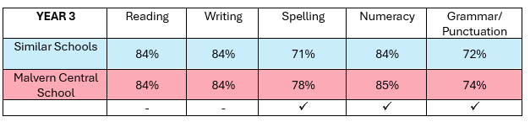

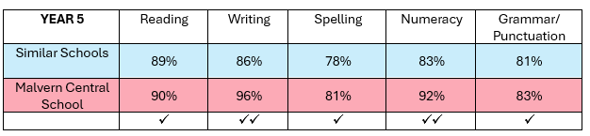
So, we can see that we have strong achievement data across the board, however our school goals outlined in the Strategic Plan 2024 – 2028 and the Annual Implementation Plan for 2024 speak of progressing the number of students in the Exceeding band in NAPLAN Reading, Writing and Numeracy.
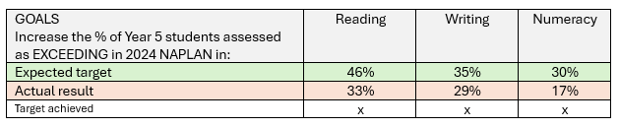
We have fallen short of these goals last year and will need to further explore the strategies around improving the NAPLAN outcomes for our high achieving students. Firstly, the teaching and learning programs, particularly in Mathematics will need to be examined to ensure high level activities and lessons are provided, to ensure further results maintenance or growth of highly able students. This speaks to differentiating lessons to provide suitable challenge., not merely ‘teaching to the middle’. Secondly, the Year 5 teaching staff have indicated that more work needs to be done on worded problem-solving as this is largely the structure of NAPLAN, and despite us standing firm on not ‘teaching to the test’, our students need greater support and exposure to worded problems with up to three parts to solve or consider. Problem solving has been embedded into the 2025 Mathematics program to address this issue. Again, I wish to point out that each year we lose up to 25 Year 4 students to independent schools and a large majority of these are in the ‘Exceeding’ range as identified from Year 3 NAPLAN. This goes some way to explain the low level of students excelling in NAPLAN, however our Strategic Plan, newly designed in May of 2024, sets out the challenge that over 4 years this percentage of Exceeding students will rise. We are therefore committed to explore and improve:
· The level of differentiation and challenge in lessons
· The explicit teaching of reading and writing skills
· Identifying ‘gaps’ in student knowledge when looking at NAPLAN data and addressing these
· Exploring alternate assessment platforms through ACER (Australian Council for Educational Research)
· Regular exposure to worded problems in mathematics and applying NAPLAN marking guide to writing in Year 2 – 5

Wellbeing
WELLBEING
As a method of measuring student wellbeing, each year students from Year 4 to Year 6 complete the Attitudes to School Survey, a comprehensive set of student-friendly questions ranging from sense of confidence to student voice and agency, emotional awareness to teacher concern. The past two years have including more individualised questions on help seeking, physical and mental health and life satisfaction. For the Annual Report, we are very pleased to see that we have a high proportion of Year 4 – 6 students feeing a sense of connectedness to school, 88.1%, significantly higher than both Similar and State schools. We can achieve this through providing high quality teachers that connect well with all students, classrooms that are calm and orderly with high expectations and respect and school programs and special events that students enjoy and look forward to. The Sense of Connectedness factor this year, is the highest result over 5 years.
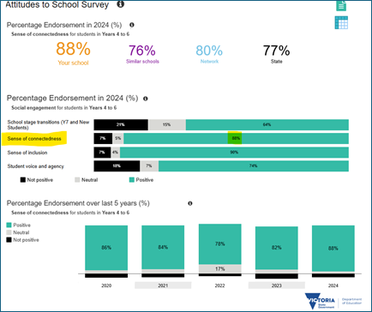
The other factor represented in the Annual Report data is the Management of Bullying, which again we scored significantly higher than Similar and State school, indicating that 82.6% of students believe they haven’t been bullied and that Malvern Central School manages behaviours and reports of bullying well, however as a school, it is our duty to understand what the other 17.4% (27/159 students) of responses are and what they have, or are, experiencing at school.
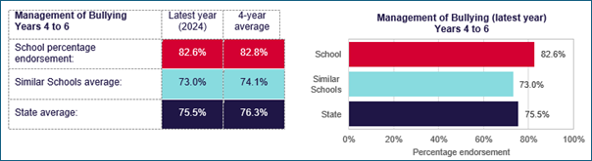
Our School Strategic Plan identifies 3 other features of the Attitudes to School Survey in which we will measure student wellbeing over the next 4 years. In 2024, the school selected the following goals:
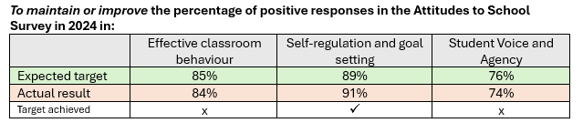
The highlights of our year in Wellbeing include whole school goal setting in which students have a greater understanding of the work that is required to achieve a next milestone or improve their work, particularly in writing. This gives students greater agency over their work and effort as they improve their skills or understandings. In 2024, Spring Rd campus introduced a Reflection Room. A place for students to attend if there had been behavioural, social or wellbeing concerns. Students are asked to reflect on a behaviour, make amends or restore a relationship and consider future behaviours, all in a supported space with staff working with the students in a calm, respectful manner. We firmly believe this has had a positive impact on classroom and playground behaviour.

Engagement
ENGAGEMENT
For the Annual Report, the school is required to provide commentary around student attendance rates, in order to make a connection to student engagement.
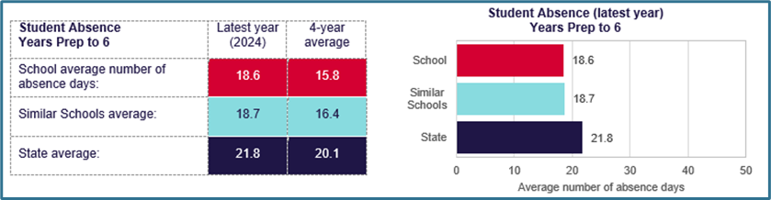
This data shows that the average number of days that Malvern Central School students are absent is 15.8 days, a slightly lower number than our Similar school counterparts or State schools. Our school records indicate that the vast majority of this absence is due to family holidays or illness. In 2024, 65 % of our students from Foundation to Year 6 recorded between 0 – 19.5 absent days which is a typical range of absence. The further 35% of students recording above 20 days are usually due to extended family holidays, spending a full school term interstate of overseas and in very rare circumstances, school refusal which is managed by the Wellbeing Team in conjunction with the family.

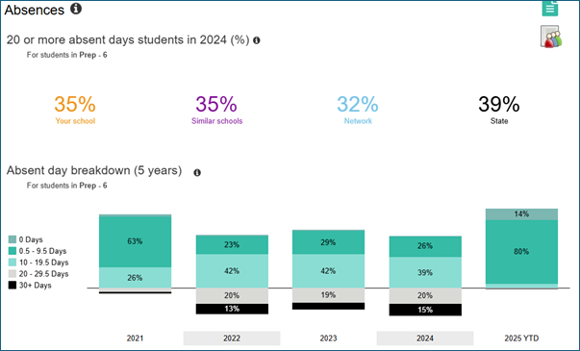
Attendance data can always improve, and the school actively encourages teachers to contact a family after 2 days when no reason is given for an absence.
For Malvern Central School, we measure engagement, again through the Attitudes to School Survey where students can be asked specific questions about learning challenge, confidence and stimulated learning. These factors are included in our Strategic Plan and will be tracked over the next four years. The goals for Engagement are:
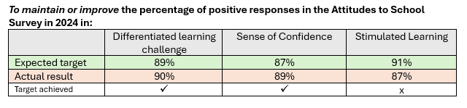
One of the highlights in 2024 for Engagement would be camps for Years 3, 4, 5 & 6. Despite financial constraints due to Time in Lieu payments introduced for teaching staff last year, our school has continued the camp program offering a camp at each of the year levels. All camps are within 4 hours of Melbourne to keep costs down and our Family 4 Families fund, a fund set up by the Parent’s Club in 2024, helps cover the costs of camps for financially vulnerable parents.
Another highlight would be projects and special interest events where student learning is shared and parents and families visit the classrooms to interact with the students. Last year saw Year 6 present their Spirits of Our Nation projects, Year 2 Science Fair, Year 3 Cultural celebrations, Year 1 Farm to Plate and Year 4 Biomes. The school continues to offer a vast array of sporting competitions through interschool sport and all year levels schedule excursions and incursions to enhance learning and engagement.

Other highlights from the school year
In 2024, Malvern Central School performed 'Seussical the Musical', demonstrating the talents of our students through singing, acting and dance. It was a fun, vibrant and colourful production made possible by the Performing Arts program and teaching staff. The production was well supported by a large team of teachers, support staff and parents who helped out with costumes, sets and makeup. Performed over two nights at Lauriston Girls' School, this was a testament to how engaged our community is to our students, making this large-scale production a reality.
Also in 2024, we underwent a School Review analysing data and a variety of surveys from the last 4 years to develop a new Strategic Plan. This was indeed a highlight as the panel were impressed by the school, the quality of our programs and the achievement our students have accomplished. The panel interviewed all stakeholders; students, teachers, parents and the Leadership Team. An overwhelming sentiment was that are students were happy, enjoyed learning and felt connected and proud to be a part of the Malvern Central community.
Our Parents' Club, throughout the year, hosted a wide range of school, parent and community events. These included school discos, hot dog days, Mother's and Father's Day stalls, Mother's Day lunch and Father's Day lawn bowling day and dinner and in August hosted a Gala Ball at Kooyong Lawn Tennis Centre. A highlight of the year and a major fundraising event that was generously supported by the parent community.

Financial performance
The school's financial position at the end of 2024 was very sound. Budgets were well managed to ensure spending and expenditure was in line with school initiatives and contributed to providing high quality teaching and learning programs for our students. This money held over into 2025 will allow for further refurbishment of school grounds and learning spaces and the continued provision of computers, iPads and assessment tools essential for student progress tracking.
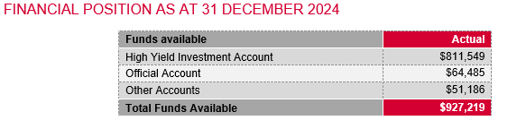
There was no extraordinary revenue or expenditure items.
The school council continued contracts with TheirCare (Out of School Care program) and with various sporting clubs including netball, tennis, violin, soccer, athletics and coding club.
Funding to the school in 2024 included parent contributions/locally raised funds $815, 875, fundraising $31,979, Department of Education quarterly grants $427,982 for the running of the school operations and Department funded staffing budget $4,864,233.

Performance Summary
The Performance Summary for government schools provides an overview of how this school is contributing to the objectives of the Education State and how it compares to other Victorian government schools.
All schools work in partnership with their school community to improve outcomes for children and young people. Sharing this information with parents and the wider school community helps to support community engagement in student learning, a key priority of the Framework for Improving Student Outcomes 2.0 (FISO 2.0).
Refer to the ‘How to read the Annual Report’ section for help on how to interpret this report.
SCHOOL PROFILE

Enrolment Profile
A total of 508 students were enrolled at this school in 2024, 259 female and 249 male.
8 percent of students had English as an additional language and NDP percent were Aboriginal or Torres Strait Islander.

Overall Socio-Economic Profile
The overall school’s socio-economic profile is based on the school's Student Family Occupation and Education index (SFOE).
SFOE is a measure of socio-educational disadvantage of a school, based on educational and employment characteristics of the parents/carers of students enrolled at the school. Possible SFOE band values are: Low, Low-Medium, Medium and High. A ‘Low’ band represents a low level of socio-educational disadvantage, a ‘High’ band represents a high level of socio-educational disadvantage.
This school’s SFOE band value is: Low

Parent Satisfaction Summary
The percentage endorsement by parents on their General School Satisfaction, as reported in the annual Parent/Caregiver/Guardian Opinion Survey.
Percent endorsement indicates the percent of positive responses (agree or strongly agree) from parents who responded to the survey.

Parent Satisfaction | Latest year (2024)
School percentage endorsement: | 81.0%
State average (primary schools): | 81.6%

School Staff Survey
The percent endorsement by staff on School Climate, as reported in the annual School Staff Survey.
Percent endorsement indicates the percent of positive responses (agree or strongly agree) from staff who responded to the survey.
Data is suppressed for schools with three or less respondents to the survey for confidentiality reasons.
School Climate | Latest year (2024)
School percentage endorsement: | 74.2%
State average (primary schools): | 77.7%
LEARNING
Key: ‘Similar Schools’ are a group of Victorian government schools that are like this school, taking into account the school’s socioeconomic background of students, the number of non-English speaking students and the size and location of the school.

Teacher Judgement of student achievement against the Victorian Curriculum
Percentage of students working at or above age expected standards in English and Mathematics.

English  Years Prep to 6 | Latest year (2024)
School percentage of students at or above age expected standards: | 97.7%
Similar Schools average: | 95.2%
State average: | 86.4%

Mathematics  Years Prep to 6 | Latest year (2024)
School percentage of students at or above age expected standards: | 98.1%
Similar Schools average: | 95.7%
State average: | 85.9%

LEARNING (continued)
Key: ‘Similar Schools’ are a group of Victorian government schools that are like this school, taking into account the school’s socioeconomic background of students, the number of non-English speaking students and the size and location of the school.

NAPLAN
Percentage of students in the Strong or Exceeding proficiency levels in NAPLAN.
Note: The NAPLAN test was revised in 2023. As a result, a 2-year average has been provided for 2024.

Reading  Year 3 | Latest year (2024) | 2-year average
School percentage of students in Strong or Exceeding: | 84.0% |  | 84.1%
Similar Schools average: | 84.4% |  | 84.8%
State average: | 68.7% |  | 69.2%

Reading  Year 5 | Latest year (2024) | 2-year average
School percentage of students in Strong or Exceeding: | 89.6% |  | 88.9%
Similar Schools average: | 89.0% |  | 90.5%
State average: | 73.0% |  | 75.0%

Numeracy  Year 3 | Latest year (2024) | 2-year average
School percentage of students in Strong or Exceeding: | 85.2% |  | 84.1%
Similar Schools average: | 83.8% |  | 84.0%
State average: | 65.5% |  | 66.4%

Numeracy  Year 5 | Latest year (2024) | 2-year average
School percentage of students in Strong or Exceeding: | 91.7% |  | 87.9%
Similar Schools average: | 83.4% |  | 84.4%
State average: | 67.3% |  | 67.6%

LEARNING (continued)
Key: ‘Similar Schools’ are a group of Victorian government schools that are like this school, taking into account the school’s socioeconomic background of students, the number of non-English speaking students and the size and location of the school.

NAPLAN 2022
Percentage of students in the top three bands of testing in NAPLAN.

Reading  Year 3 | (2022)
School percentage of students in the top three bands: | 86.8%
Similar Schools average: | 89.9%
State average: | 76.6%

Reading  Year 5 | (2022)
School percentage of students in the top three bands: | 86.0%
Similar Schools average: | 86.7%
State average: | 70.2%

Numeracy  Year 3 | (2022)
School percentage of students in the top three bands: | 84.4%
Similar Schools average: | 79.5%
State average: | 64.0%

Numeracy  Year 5 | (2022)
School percentage of students in the top three bands: | 79.1%
Similar Schools average: | 72.5%
State average: | 54.2%

WELLBEING
Key: ‘Similar Schools’ are a group of Victorian government schools that are like this school, taking into account the school’s socioeconomic background of students, the number of non-English speaking students and the size and location of the school.

Student Attitudes to School – Sense of Connectedness
The percentage endorsement on Sense of Connectedness factor, as reported in the Attitudes to School Survey completed annually by Victorian government school students, indicates the percent of positive responses (agree or strongly agree).

Sense of Connectedness  Years 4 to 6 | Latest year (2024) | 4-year average
School percentage endorsement: | 88.1% |  | 83.3%
Similar Schools average: | 75.9% |  | 76.1%
State average: | 76.8% |  | 77.9%

Student Attitudes to School – Management of Bullying
The percentage endorsement on Management of Bullying factor, as reported in the Attitudes to School Survey completed annually by Victorian government school students, indicates the percent of positive responses (agree or strongly agree).

Management of Bullying  Years 4 to 6 | Latest year (2024) | 4-year average
School percentage endorsement: | 82.6% |  | 82.8%
Similar Schools average: | 73.0% |  | 74.1%
State average: | 75.5% |  | 76.3%

ENGAGEMENT
Key: ‘Similar Schools’ are a group of Victorian government schools that are like this school, taking into account the school’s socioeconomic background of students, the number of non-English speaking students and the size and location of the school.

Average Number of Student Absence Days
Absence from school can impact on students’ learning. Common reasons for non-attendance include illness and extended family holidays.

Student Absence  Years Prep to 6 | Latest year (2024) | 4-year average
School average number of absence days: | 18.6 |  | 15.8
Similar Schools average: | 18.7 |  | 16.4
State average: | 21.8 |  | 20.1

Attendance Rate (latest year)
Attendance rate refers to the average proportion of formal school days students in each year level attended.
 | Prep | Year 1 | Year 2 | Year 3 | Year 4 | Year 5 | Year 6
Attendance Rate by year level (2024): | 91% | 91% | 90% | 92% | 90% | 89% | 90%

Financial Performance and Position

Financial Performance - Operating Statement Summary for the year ending 31 December, 2024
Revenue | Actual
Student Resource Package | $4,864,233
Government Provided DET Grants | $427,982
Government Grants Commonwealth | $5,338
Government Grants State | $0
Revenue Other | $31,979
Locally Raised Funds | $815,875
Capital Grants | $0
Total Operating Revenue | $6,145,406

Equity ¹ | Actual
Equity (Social Disadvantage) | $7,346
Equity (Catch Up) | $0
Equity (Social Disadvantage – Extraordinary Growth) | $0
Equity Total | $7,346

Expenditure | Actual
Student Resource Package ² | $4,731,256
Adjustments | $0
Books & Publications | $4,175
Camps/Excursions/Activities | $140,125
Communication Costs | $23,005
Consumables | $110,021
Miscellaneous Expense ³ | $38,789
Professional Development | $23,109
Equipment/Maintenance/Hire | $58,794
Property Services | $180,347
Salaries & Allowances ⁴ | $41,997
Support Services | $282,491
Trading & Fundraising | $80,521
Motor Vehicle Expenses | $0
Travel & Subsistence | $0
Utilities | $55,247
Total Operating Expenditure | $5,769,877
Net Operating Surplus/-Deficit | $375,529
Asset Acquisitions | $140,034
- The equity funding reported above is a subset of the overall revenue reported by the school.
- Student Resource Package Expenditure figures are as of 16 Feb 2025 and are subject to change during the reconciliation process.
- Miscellaneous Expenses include bank charges, administration expenses, insurance and taxation charges.
- Salaries and Allowances refers to school-level payroll.

FINANCIAL POSITION AS AT 31 DECEMBER 2024

Funds available | Actual
High Yield Investment Account | $811,549
Official Account | $64,485
Other Accounts | $51,186
Total Funds Available | $927,219

Financial Commitments | Actual
Operating Reserve | $173,773
Other Recurrent Expenditure | $23,280
Provision Accounts | $0
Funds Received in Advance | $0
School Based Programs | $0
Beneficiary/Memorial Accounts | $0
Cooperative Bank Account | $0
Funds for Committees/Shared Arrangements | $0
Repayable to the Department | $0
Asset/Equipment Replacement < 12 months | $0
Capital - Buildings/Grounds < 12 months | $0
Maintenance - Buildings/Grounds < 12 months | $0
Asset/Equipment Replacement > 12 months | $0
Capital - Buildings/Grounds > 12 months | $0
Maintenance - Buildings/Grounds > 12 months | $0
Total Financial Commitments | $197,053

All funds received from the Department of Education, or raised by the school, have been expended, or committed to subsequent years, to support the achievement of educational outcomes and other operational needs of the school, consistent with department policies, School Council approvals and the intent/purposes for which funding was provided or raised.

